Data Engineering
Data Engineering is basically about collecting, cleaning, and moving data so other people and systems can use it easily.
- Data sources = factories (apps, websites, databases, sensors)
- Data engineer = designs and maintains pipelines
- Data warehouse/lake = storage warehouse
- Data analysts / data scientists = people who use the stored data to make decisions
If the pipes break or data is messy, analysis becomes wrong or impossible.
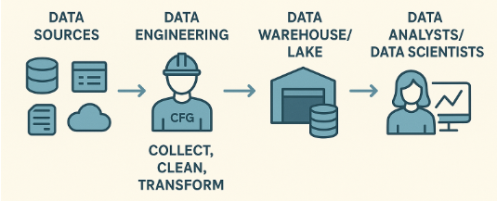
OLTP & OLAP
OLTP = Online Transaction Processing
OLTP systems handle day-to-day business operations
Real-time example: Online Shopping App
When you:
- Place an order
- Make a payment
- Update your address
- Cancel an order
All these actions happen in an OLTP system.
Why?
- Needs to be fast
- Handles many users at the same time
- Each operation affects small amounts of data
OLTP characteristics
- Many small transactions
- Mostly INSERT, UPDATE, DELETE
- Data is highly normalized
- Response time in milliseconds
- Example databases:
  - MySQL
  - PostgreSQL
  - Oracle
  - SQL Server
Few examples of OLTP systems are everywhere in daily life — anytime data is created or updated in real time, it’s OLTP.
🏦 Banking & Finance
- ATM cash withdrawal
- Money transfer between accounts
- Credit/debit card swipe
- Updating account balance
Each transaction must be accurate, fast, and reliable
🏥 Healthcare
- Patient registration
- Doctor updating diagnosis
- Booking appointments
- Updating medical records
Many users, small updates, zero tolerance for errors
✈️ Airline / Travel Booking
- Flight ticket booking
- Seat selection
- Ticket cancellation
- Payment confirmation
Two users cannot book the same seat at the same time
🛍️ Retail / POS Systems
- Billing at a store counter
- Inventory stock update after sale
- Applying discounts
- Processing returns
📱 Social Media / Apps
- Posting a comment
- Liking a post
- Following a user
- Updating profile info
🚕 Ride-hailing Apps (Uber / Lyft)
- Booking a ride
- Assigning a driver
- Updating ride status
- Calculating fare
OLAP = Online Analytical Processing
OLAP systems analyze historical data to make decisions. They are used for reporting, dashboards, and analytics.
Real-time example: Business Analytics
A company asks:
- How many orders were placed last month?
- Which product sold the most this year?
- Which city has the highest revenue?
These questions are answered using an OLAP system.
OLAP characteristics
- Read-heavy workloads
- Large aggregations (SUM, COUNT, AVG)
- Data is often denormalized
- Queries scan millions of rows, Response time in seconds to minutes
- Example tools:
  - Snowflake
  - BigQuery
  - Redshift
  - Databricks
  - Synapse
How OLTP & OLAP work together -
- User places order → OLTP
- Data is periodically copied → ETL / ELT
- Stored in data warehouse → OLAP
- Reports & dashboards are built
Normalized (OLTP) vs De-Normalized (OLAP)
What is Normalization? (OLTP)
Breaking data into multiple related tables to avoid duplication
Example: Online Shopping (OLTP)
Un-normalized table (bad for OLTP)
order_id | customer_name | customer_email | product_name | product_price
Customer info repeats for every order → data duplication
Normalized design (OLTP way)
Customers table
customer_id | name | email
Orders table
order_id | customer_id | order_date
Products table
product_id | product_name | price
Order_Items table
| order_id | product_id | quantity |
✔ No duplication
✔ Update email in one place
✔ High data integrity
OLTP SQL example
UPDATE customers
SET email = 'new@email.com'
WHERE customer_id = 101;
Only one row updated → fast & safe
What is De-Normalization? (OLAP)
Combining data into fewer tables to make reading & analysis faster
Same data in OLAP (De-Normalized)
Sales_Fact table
order_id | order_date | customer_name | product_name | category | price | quantity | total_amount
Some data is repeated
That’s intentional for performance
OLAP SQL example
SELECT category, SUM(total_amount)
FROM sales_fact
GROUP BY category;
System | Data Style | Reason
OLTP | Normalized | Fast writes, consistency
OLAP | De-Normalized | Fast reads, easy analysis
Dimensional Data Modeling
It is a way of designing data for analytics (OLAP) so that:
- Data is easy to understand
- Queries are fast
- Business questions are easy to answer
It is NOT meant for transactions. It is meant for reporting, dashboards, and analysis.
Core Concepts: Fact & Dimension Tables
Fact Table (The “What happened”)
Examples of facts:
- Sales amount
- Quantity sold
- Revenue
- Discount
- Profit
Dimension Table (The “Context”)
Examples of dimensions:
- Customer
- Product
- Date
- Store
- Location
Real-time Example: Online Shopping
Business question:
“What is the total sales by product category per month?”
Sales_Fact table
order_id | order_date | customer_name | product_name | category | price | quantity | total_amount
SELECT Month(order_date) As Month, category, SUM(total_amount) As Total_Sales
FROM sales_fact
GROUP BY Month(order_date),category;
Dimension Tables
dim_date
| date_id | date | month | quarter | year |
dim_product
| product_id | product_name | category | brand |
dim_customer
| customer_id | name | city | country |
STAR Schema
A central fact table connected directly to multiple dimension tables
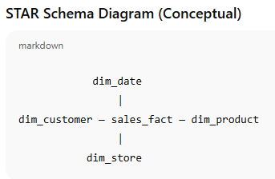
SNOWFLAKE Schema
A more normalized version of Star Schema. Dimensions are split into sub-dimensions
Example (Product dimension split)
Instead of:
dim_product(product_id, product_name, category, brand)
We split into:
dim_product(product_id, product_name, category_id)
dim_category(category_id, category_name,brand_id)
dim_brand(brand_id,brand_name)
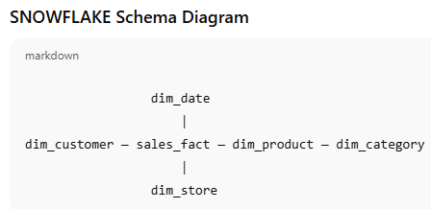
OLTP Normalization vs OLAP Snowflake Normalization
OLTP normalization and OLAP snowflaking solve DIFFERENT problems.
OLTP Normalization (3NF) — Write-Optimized
Normalization level:
- Strict 3NF (or higher)
- Every attribute stored exactly once
- Heavy use of many small tables
OLTP Example (Customers)
customers
---------
customer_id (PK)
first_name
last_name
email
phone
address_id (FK)
addresses
---------
address_id (PK)
street
city
state
country
zip
Why?
- Customer changes address → update only ONE row
- No duplicate address data
- High consistency
OLAP Snowflake Normalization — Read-Optimized
Normalization level:
- Light normalization
- ONLY within dimension tables
- Fact table stays denormalized in structure
Snowflake normalization is:
- Optional
- Shallow
- Used only when dimensions grow complex
CUSTOMER: OLTP vs OLAP
Purpose:
- Capture current state
- Used by applications

CREATE TABLE customers (
customer_id INT PRIMARY KEY,
first_name VARCHAR(50),
last_name VARCHAR(50),
email VARCHAR(100),
phone VARCHAR(20),
status_id INT,
address_id INT,
created_at TIMESTAMP,
updated_at TIMESTAMP
);
Characteristics:
✔ Highly normalized
✔ Supports updates
✔ Holds only current data
✔ Foreign keys everywhere
OLAP: dim_customer table (Analytical)
Purpose:
- Describe customers for analysis
- Preserve history
CREATE TABLE dim_customer (
customer_key INT PRIMARY KEY, -- surrogate key
customer_id INT, -- business key from OLTP
full_name VARCHAR(100),
email VARCHAR(100),
city VARCHAR(50),
state VARCHAR(50),
country VARCHAR(50),
customer_segment VARCHAR(50),
start_date DATE,
end_date DATE,
is_current BOOLEAN
);
Characteristics:
✔ Denormalized (city/state inside)
✔ Historical tracking (SCD) Type - 2
✔ Rare updates
✔ Optimized for reads
🔹 PRODUCT: OLTP vs OLAP
OLTP: products
CREATE TABLE products (
product_id INT PRIMARY KEY,
product_name VARCHAR(100),
brand_id INT,
category_id INT,
price DECIMAL(10,2),
created_at TIMESTAMP
);
brands(brand_id, brand_name)
categories(category_id, category_name)
OLAP: dim_product (STAR)
CREATE TABLE dim_product (
product_key INT PRIMARY KEY,
product_id INT,
product_name VARCHAR(100),
brand_name VARCHAR(50),
category_name VARCHAR(50),
subcategory_name VARCHAR(50)
);
OLAP: dim_product (SNOWFLAKE)
dim_product
-----------
product_key
product_id
product_name
brand_key
category_key
dim_brand
---------
brand_key
brand_name
dim_category
------------
category_key
category_name
Staging Layer (Landing / Raw Zone)
The first stop for data coming from source systems (OLTP, APIs, files, logs). Think of it as a temporary holding area.
Example (Customer data from OLTP)
Source (OLTP):
customers
---------
customer_id
first_name
last_name
email
address_id
updated_at
Staging table:
stg_customers
-------------
customer_id
first_name
last_name
email
address_id
updated_at
load_date
Almost identical to source
Just adds metadata like load_date
Core Layer (Data Warehouse / Curated Layer)
The cleaned, structured, business-ready layer used for analytics.
This is where:
- Fact & Dimension tables live
- Business logic is applied
- Historical data is maintained
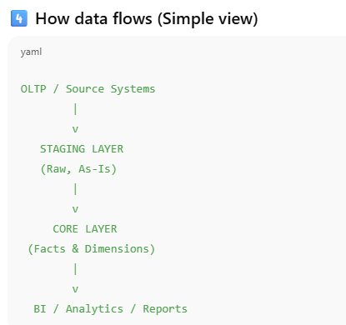
ODS vs Staging
Staging is a temporary raw data landing zone, while ODS is a cleaned, integrated, near-real-time data store used for operational reporting before data is transformed into an analytical warehouse.
ODS is a cleaned, integrated, near-real-time data store used for operational reporting. Clean, current snapshot of business data
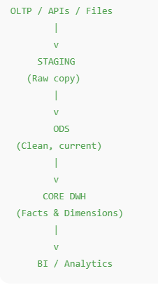
Memory shortcut
- Staging = Raw copy
- ODS = Clean current view
- Core = Historical analytics

What is a Data Lake
A Data Lake is a central place to store large amounts of data (Structured, Semi-structured, Unstructured) in its raw form, exactly as it comes from different sources.
What kind of data goes into a Data Lake?
- Structured → tables (CSV, database exports)
- Semi-structured → JSON, XML, logs
- Unstructured → images, videos, text, PDFs
Feature | Data Lake | Data Warehouse
Data format | Any | Structured only
Schema | On read | On write
Data state | Raw | Processed
Cost | Low | Higher
Use cases | ML, exploration | BI, reporting

What is Data Lakehouse
A Data Lake + Data Warehouse capabilities combined. One platform for storage, analytics, and ML
Characteristics:
- Uses data lake storage (S3, ADLS, GCS)
- Adds ACID transactions
- Supports BI, SQL, ML, streaming
- Schema enforcement + evolution
What is Delta Lake
Delta Lake is the technology that makes a Data Lake behave like a Lakehouse
Medallion Architecture
Bronze Layer
Raw data
- Ingested as-is
- Append-only
- Full history
Silver Layer
Clean & standardized data
- Deduplicated
- Joined across sources
- Quality checks applied
Business-ready data
- Aggregated
- Fact & dimension tables
- BI-friendly
A layered design pattern for building reliable data pipelines in a Lakehouse.
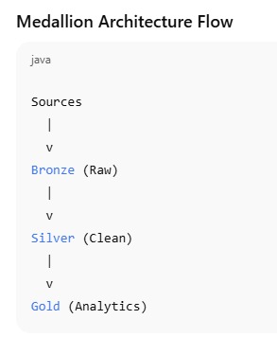
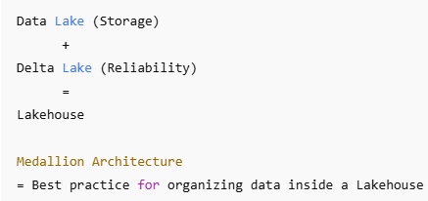
- Data Lake: “Cheap storage for raw data”
- Lakehouse: “Data lake + warehouse capabilities”
- Delta Lake: “Enables ACID transactions on data lakes”
- Medallion Architecture: “Bronze-Silver-Gold layered design for reliable data pipelines”

Azure Data Factory (ADF)
Data movement & orchestration tool. It fits between source systems and data storage / compute.
What ADF does:
- Extract data from:
  - OLTP databases
  - SaaS apps
  - APIs
  - Files
- Load data into:
  - Data Lake (ADLS)
  - Synapse
- Schedule & monitor pipelines
ADF role in layers:
Layer | Role
Bronze | Ingest raw data
Silver | Trigger Pipelines
Gold | Schedule refresh

Databricks
Compute & processing engine (Spark-based) On top of the Data Lake
What Databricks does:
- Clean & transform data (ETL/ELT)
- Implement Medallion Architecture
- Build Delta Lake tables
- Perform:
  - Batch processing
  - Streaming
  - Machine Learning
- Handle big joins & aggregations
Databricks role in layers:
Layer | Role
Bronze | Ingest raw data
Silver | Clean & standardize
Gold | Build fact & dimensions

Azure Synapse Analytics
Analytics & SQL querying platform. Query & serve data to business users.
Synapse has 2 roles:
Dedicated SQL Pool (Traditional DWH)
- Stores data in tables
- Strong BI performance
- MPP engine
Serverless SQL Pool (Lakehouse-style)
- Queries data directly from Data Lake
- No data movement required
Layer | Role
Gold | Query curated data
BI | Power BI integration

How they work together (Step-by-step flow)
Step 1: Ingestion
- ADF pulls data from OLTP
- Writes raw data to Bronze layer in ADLS
Step 2: Processing
- Databricks reads Bronze
- Cleans & transforms → Silver
- Builds Fact & Dimension tables → Gold
Step 3: Analytics
- Synapse queries Gold tables
- Power BI builds dashboards
Azure Data Factory is used for data ingestion and orchestration, Databricks handles large-scale data processing and implements the Medallion Architecture using Delta Lake on ADLS, and Azure Synapse Analytics serves as the analytical SQL layer for querying curated data and powering BI dashboards.
ADF is responsible for ingestion and orchestration across all layers, Databricks performs the actual data transformations from Bronze to Silver to Gold, Synapse Serverless can query curated data directly from ADLS, and ADF loads data into Synapse Dedicated SQL pools when a traditional data warehouse serving layer is required.
When does Synapse read directly from ADLS (bypassing Databricks)?
Serverless SQL (Common)
Use case:
- Ad-hoc analysis
- Simple reporting
- Lightweight BI queries
- Cost-sensitive environments
How it works:
- Data already exists in ADLS (Silver or Gold)
- Stored as Parquet / Delta
- Synapse Serverless SQL reads files directly
SELECT category, SUM(amount)
FROM OPENROWSET(
BULK 'https://adlsg2/silver/sales/',
FORMAT = 'DELTA'
);
When does ADF load data INTO Synapse?
Dedicated SQL Pool (Traditional DWH)
Use case:
- Enterprise BI
- Very high concurrency
- Mature reporting environment
- Strict performance SLAs
OLTP → ADF → Synapse Dedicated SQL Pool
ADLS (Gold) → ADF → Synapse Dedicated SQL Pool
Question | Answer
Who loads Bronze? | ADF
Who transforms Silver & Gold? | Databricks
Who schedules pipelines? | ADF
Who does heavy joins & SCD? | Databricks
Who queries data lake directly? | Synapse Serverless
Who stores enterprise BI tables? | Synapse Dedicated
Who moves data into Synapse? | ADF

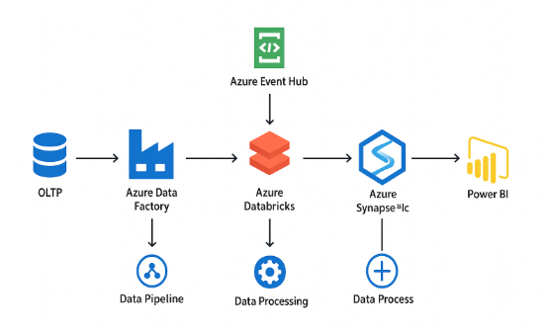
What is Azure Event Hubs?
Azure Event Hubs is a big, scalable event ingestion service for streaming data. A real-time data entry gate.
Typical data coming into Event Hubs
- Application logs(Azure services/ Non-Azure applications)
- Clickstream events (website/app)
- IoT sensor data
- Real-time transactions
- Telemetry data
Example: E-commerce backend/Payment service
{
"service": "payment",
"level": "ERROR",
"message": "Payment timeout",
"timestamp": "2025-01-12T10:15:32Z"
}
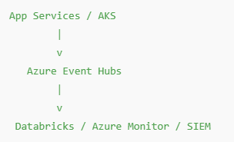
Event Hubs is not storing logs forever, just ingesting them.
Example: Clickstream Events (Web / Mobile Apps)
{
"user_id": 1023,
"event": "add_to_cart",
"product_id": 555,
"timestamp": "2025-01-12T10:18:00Z"
}
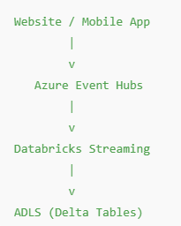
What is Azure Purview (now called Microsoft Purview)
Azure Purview tells you what data you have, where it is, who owns it, and who is allowed to use it.
What Azure Purview does (core functions)
Data Discovery (Auto-scan)
Purview automatically scans:
- ADLS
- Azure SQL
- Synapse
- Databricks
- Power BI
And discovers:
- Tables
- Files
- Columns
- Schemas
Data Catalog (Search & Understand)
Users can search:
- “customer”
- “sales”
- “revenue”
And see:
- What table contains it
- Column definitions
- Data owner
- Sample data
- Usage info
Data Classification (Sensitive Data)
Purview can detect:
- PII (email, phone, SSN)
- Financial data
- Confidential fields
And tag them automatically.
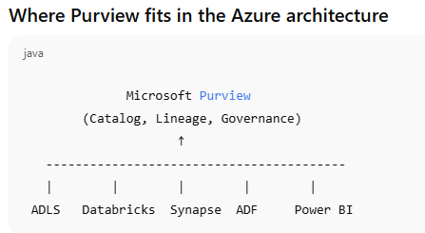
Purview does NOT store or process data
It observes and documents data

